**Initial Project plan**

**Office hours System**

**GCIS 514**

Dr. Stephen Frezza

Ayman Alotaibi

Mutaz Aldhuwayhi

Ayoob Almotairi

Wangel Tamang

1. **Project Success Criteria**

**Ob-1** view the professors schedule without going the office

**Ob-2** makes the appointment with the professors

**Ob-3** Professors view the students’ appointment

|  |  |  |  |  |
| --- | --- | --- | --- | --- |
| **Business**  **Objective** | **Stakeholder** | **Project Success Criteria** | **Measurement** | **Weight** |
| Ob-1 | Kurt E. Spence | -The users find it easy to view the schedule online (8 out of 10) | **-**accept feed back form | 40 |
| Ob-2 | Kurt E. Spence | - students find the system effective way to make an appointment with the professor (7 out of 1) | **-**feedback form | 40 |
| Ob-3 | Kurt E. Spence | - Professor find it effective to view the schedule (3 out of 5) | **-**accept feedback form | 20 |

1. **Product Vision Project Scope**

|  |  |
| --- | --- |
| For | Professors, Students |
| Who | Need to see the professors’ office hours to request a meeting. |
| The | Office Hours system |
| Is | a website |
| That | will allow students to schedule an appointment online |
| Unlike | the current way that instructor and students are doing to have a meeting. |
| Our product | will allow both instructors and students to choose their appropriate time in an easy way and through the website |

**Requirements**

System shall

* View professors’ office hours
* Allow students to select professors
* Notify students if professors cancel the appointment and vice versa
* Allow students to select their appropriate time
* Allow students to request a meeting with their professors
* Send a reminder message to professors

**context diagram**

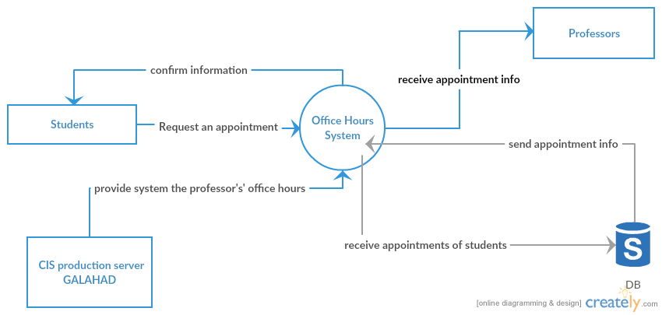

**Use case diagram**

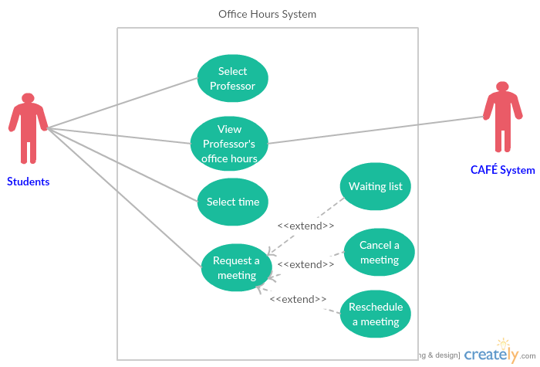

1. **Personal Commitments**

|  |  |  |  |  |
| --- | --- | --- | --- | --- |
| **Commitment** | **Made By** | **Made to** | **Date Due** | **Comments** |
| Document the project | requirement team | Dr. Stephen Frezza | May 6 | The requirement team will be responsible to document and review the project with stakeholders |
| Frist release of Office Hours System | Project team | Kurt E. Spence | May 6 | The project team will be responsible to test prototype and get acceptance from stakeholders |

1. **Study Previous Lessons Learned**

|  |  |  |  |  |  |  |
| --- | --- | --- | --- | --- | --- | --- |
| **ID** | **Date** | **Project** | **Description** | **Activity** | **Contact** | **Recommendation** |
| **1** | MAR/11/16 | Office Hours System | We have been trying to find a data that we need in our project but we have not found it yet, and the problem is we could not find the right product champion | It is a requirement in our project | John H.  Coffman | Don not start collecting the requirements if you don’t make sure you have the right product champion because he/she is going to lead you to the right way in your project |

**Project Management**

|  |  |
| --- | --- |
|  | **Next Monday** |
| **Office Hours System** |  |
| **Situation you might apply them to** | Review the requirements with stakeholders |
| **Benefits you hope to gain** | Feedback about our work |
| **Help or additional information**  **you might need** | Who has the responsibility of Microsoft SQL 2012 server in CIS production server GALAHAD |
| **Whose cooperation you**  **might need** | Mr. Kurt E. Spence |
| **Barriers that might prevent**  **you from succeeding** | if the person who has responsibility of data prevents us to get a copy of it |
| **Who could break down**  **those barriers** | Dr. Stephen Frezza |